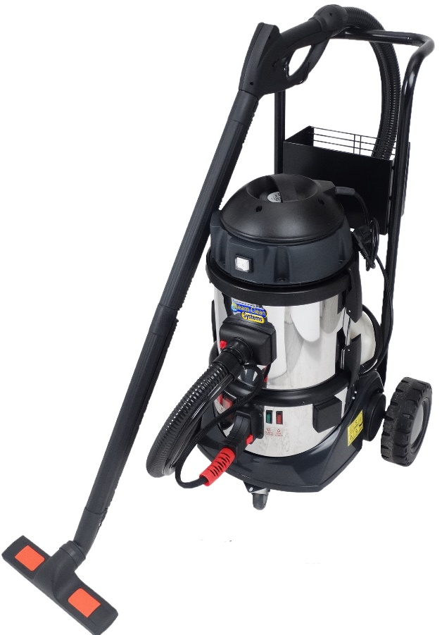
SC2000 & SC2000D Instruction Manual
www.steamcleansystems.co.uk
Partner of:

OPERATING AND SAFETY INSTRUCTIONS

- Remove all the packaging from the machine, complete a visual check for damage before plugging in the machine. If in doubt do not operate the appliance and contact Steam Clean Systems on 01903 755128
- Plastic bags, polystyrene, etc…. MUST BE KEPT OUT OF CHILDREN’S REACH
- Before powering up the appliance, make sure that the data on the serial plate has the correct power supply rating.
- DO NOT touch the appliance with wet or damp hands.
- ALWAYS disconnect the appliance from the electrical outlet when not in use.
- This appliance is only and exclusively for its intended use. The manufacturer is not held responsible for any damage due to an illegitimate use.
- DO NOT unscrew the safety valve cap during use, wait till the appliance cools down completely before opening.
- Before cleaning and maintenance, make sure that the appliance is disconnected from the power source.
- DO NOT wash the appliance or immerse in water.
- Before filling, make sure that the appliance is unplugged.
- In case of failure or operational defect, turn off the appliance. Disconnect from the electrical outlet.
- DO NOT disassemble or attempt to repair the appliance, incorrect reassembly or repair could cause a risk of fire, electric shock or injury. Any repair must be executed by a qualified service person recommended by the supplier.
- Installation must be executed according to manufacturer’s instructions (space for ventilation, room temperature)
- DO NOT operate the appliance with a damaged power lead or steam hose.
- DO NOT remove safety devices or protective cover.
- DO NOT use any substance other than water in the water bottle as it will invalidate the warranty.
- DO NOT use any corrosive or caustic substance in the detergent bottle (SC2000D Model) as it will invalidate the warranty, also could damage your respiratory system if corrosive substances are used.
- Only use a low foam chemical in the detergent bottle. Ensuring this will prevent the chemical foaming up and being drawn through the vacuum motor, which will result in damage to the motor and invalidating the warranty.

The appliance complies with the requirements of EC Directive
97/23/CE, 2004/108/CE, 2006/42/CE

O-ring Lubrication Guide

With the Lubrication kit provided in the box please ensure all O-rings are checked and kept lubricated. Failure to do this will result in the O-rings splitting and steam leaking out of the joints. In addition, the lubrication will help the fitting and removal of the attachments.
In total there are 5 O-rings that require lubricating:
- 2 Larger O-rings on the Steam outlet.
- 1 Smaller O-ring on each of the lance extension tubes. (2 x extension tubes)
- 1 Smaller O-ring on the Steam hose trigger switch end.

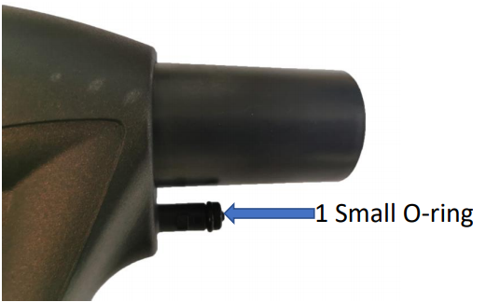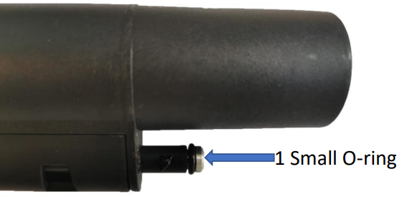

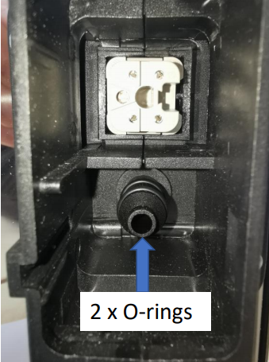

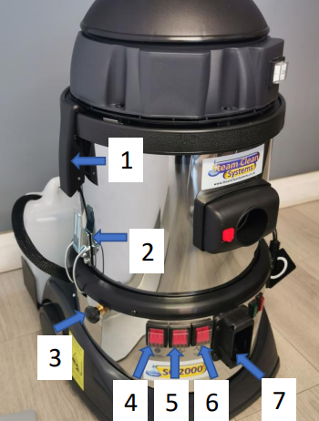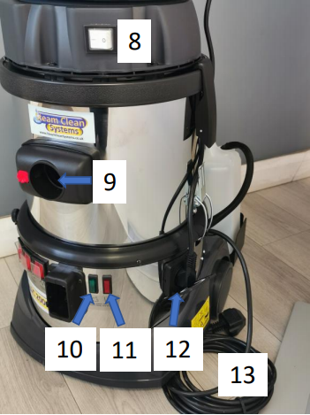
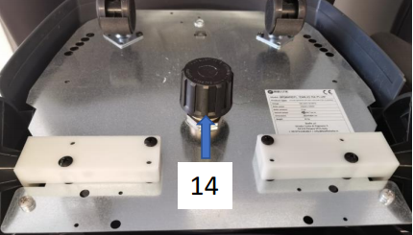
SC2000D Model SC2000 Model
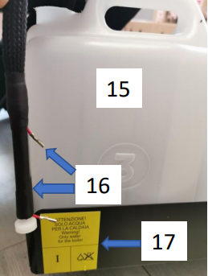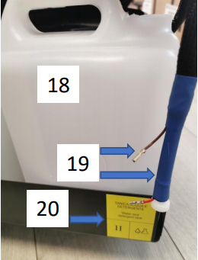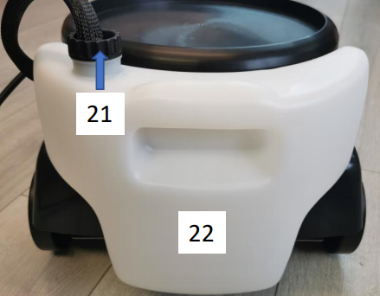

Machine Component Picture Legend

- Vacuum Unit Release x 2
- Waste Tank Release x 2
- Detergent Adjustor (SC2000D Model)
- Main On/Off Switch
- Heater 1 on/Off Switch
- Heater 2 On/Off Switch
- Steam Hose Outlet
- Vacuum Motor Main Switch
- Vacuum Hose Inlet
- Steam Ready Light
- Fault Light
- Vacuum Power Lead Socket
- Main Power Lead
- Pressure Relief Cap
- Water Bottle
- Water Load Hose + Level Sensor
- Water Bottle Indicator Label
- Detergent Bottle
- Detergent Load Hose + Level Sensor
- Detergent Bottle Indicator Label
- Water Load Hose + Level Sensor (SC2000)
- Water Bottle (SC2000)

SETUP GUIDE

- Check the safety cap is tight 14, DO NOT overtighten.
- Fit the Water bottle tray SC2000D (Fitment guide on page 8)
- Fill the water bottle 15 (SC2000D) or 22 (SC2000), Please Note: DO NOT use distilled or filtered water.
- SC2000D MUST HAVE either water/detergent in the detergent bottle or the machine will not work and constantly beep.
- The water feed hose + Level sensor 8, must be inserted all the way inside the bottle.
- Lubricate the O-rings on the steam outlet 7.
- Connect steam hose to the steam outlet 7. Ensure this is fully seated with a click.
- Plug into the power supply.
- Turn the main switch 4 on to power up the machine, you will hear the water pump run for approximately 3 minutes while it fills the boiler with water.
- Turn on the heater switch 5, this will turn on the first heater element.
- Turn on the heater switch 6, this will turn on the second heater element.
- Wait until the green light 2 lights up, then the machine is ready to use.

OPERATING INSTRUCTIONS
- DO NOT pull the machine along by the hose, it will damage the joints and can stretch the wires running up the hose. This item is not covered by any warranty and costs from £231+Vat to replace.
- Once the green light is lit, pull the trigger 23 on the steam hose to produce steam.
- If the trigger feels solid, disengage the lock 24 to operate.
- To operate the vacuum, check the power lead 12 is plugged into the base. Then ensure main switch 8 is on. Press the vacuum switch 26 on the hose to operate.
- To dispense the detergent, press the switch on the hose 25, adjust the flow of detergent using the adjuster 3.
- When the boiler requires more water, the machine will draw water in from the water bottle 15/22 via the water feed hose 16/21
- If the water or detergent runs out, a beeping sound alarm is activated. While the machine is beeping all operations are stopped, fill the water/detergent bottles and insert the feed hose 16/19 to resume operation.
- To empty the waste tank, unclip the vacuum top 1 and remove, release the waste tank 2 and pour waste water away.
- When you have finished using the machine turn off switches 6,5 and 4.
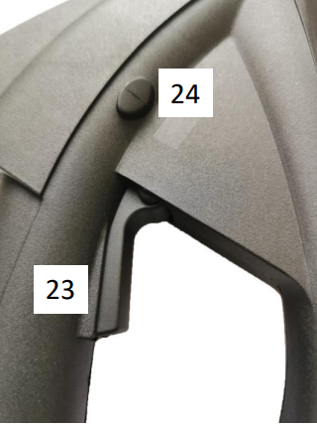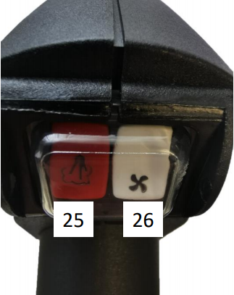
MAINTENANCE: EMPTYING/CLEANING THE BOILER

- DO NOT open the drain tap until the machine is completely cooled down.
- When the boiler is cold and not under pressure, open the drain tap 13 under the machine and drain the water from the boiler.
- If the machine is experiencing high usage, it is advisable to drain the boiler completely at least once per week. If being used for light usage then once every two weeks.
- Draining the machine regularly will allow the lime precipitate to be removed from the boiler, it also will allow the machine to self-descale increasing the reliability.
- Remove from the machine and flush out the dirty water recovery tank after every use.
- DO NOT leave water and detergent in the tanks when not in use, flush out with clean water when finished using.
- To help prolong the life of the steam and vac hose: disconnect from the machine and store it hanging up, avoid putting stress on the hose by hanging it with a gentle curve. NOT bent back on its self or hung over a door.
WHEN YOU FINISH WORKING, TURN OFF ALL THE SWITCHES, UNPLUG THE APPLIANCE AND KEEP IN A DRY PLACE.

Transport Trolleys are available with the SC2000 and the SC2000D
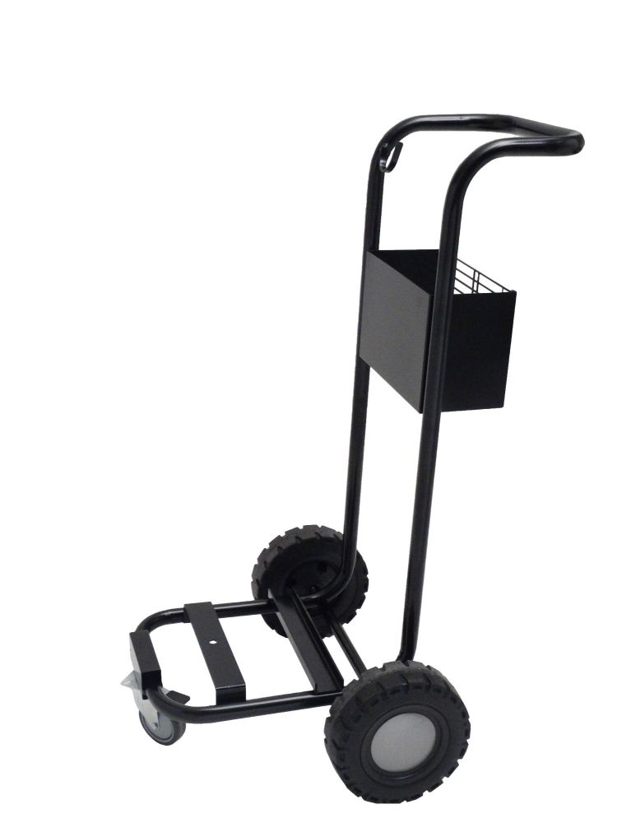
Robust Steel Trolley with Rubber Tyres
Call for Details

Bottle Tray Fitment Guide

Remove the vacuum unit and waste tank from the machine and turn the Base of the steam cleaner upside down.
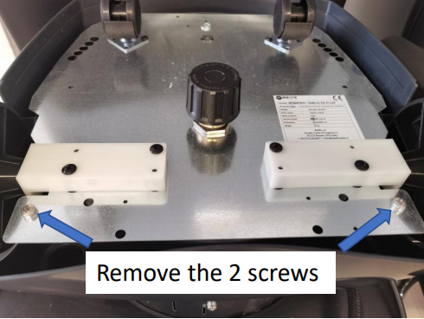
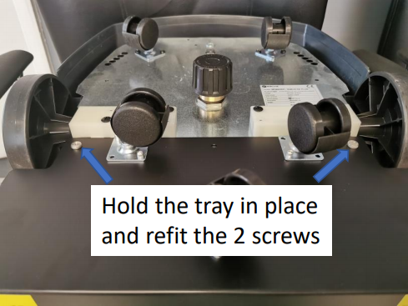
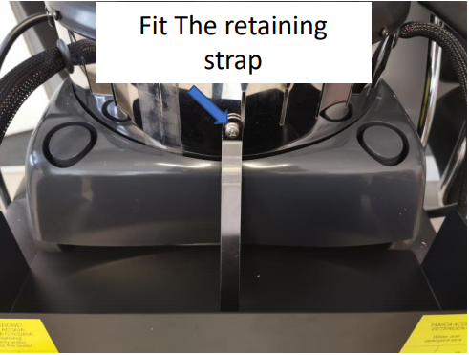

To complete the installation:
Place the bottles in the tray with the load hose’s fully pushed in.

Standard SC2000/D Tools

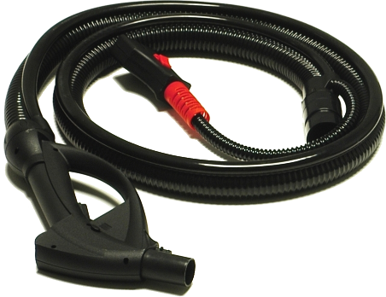
CVP
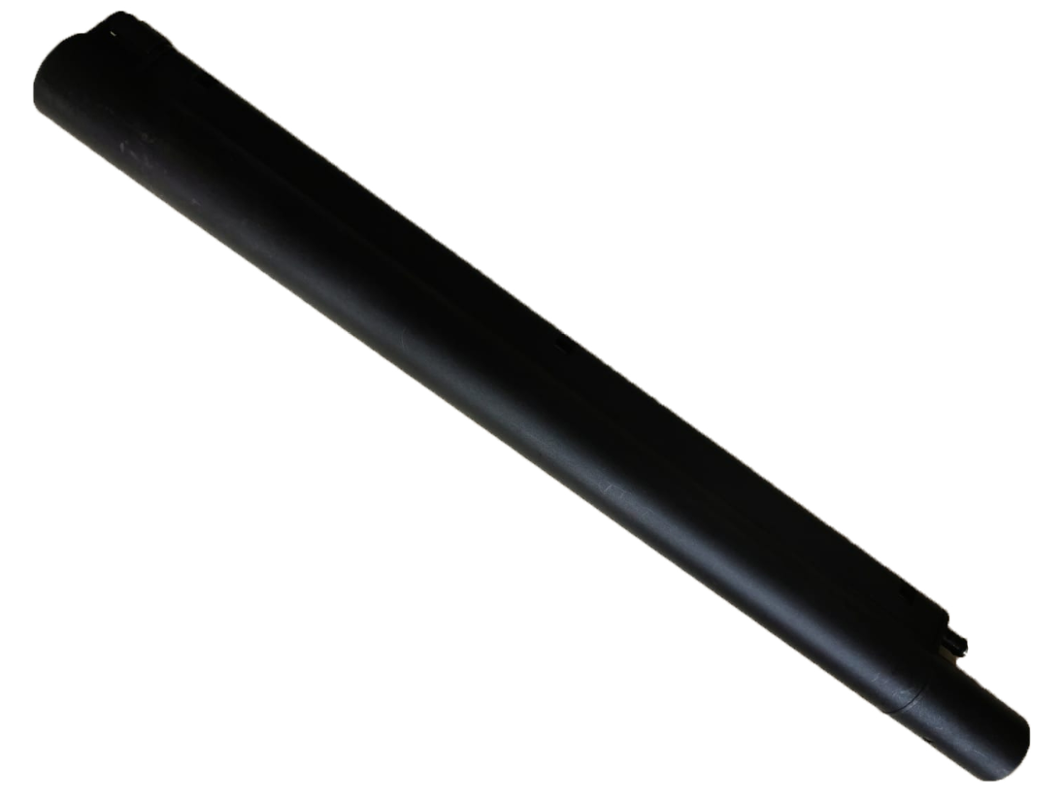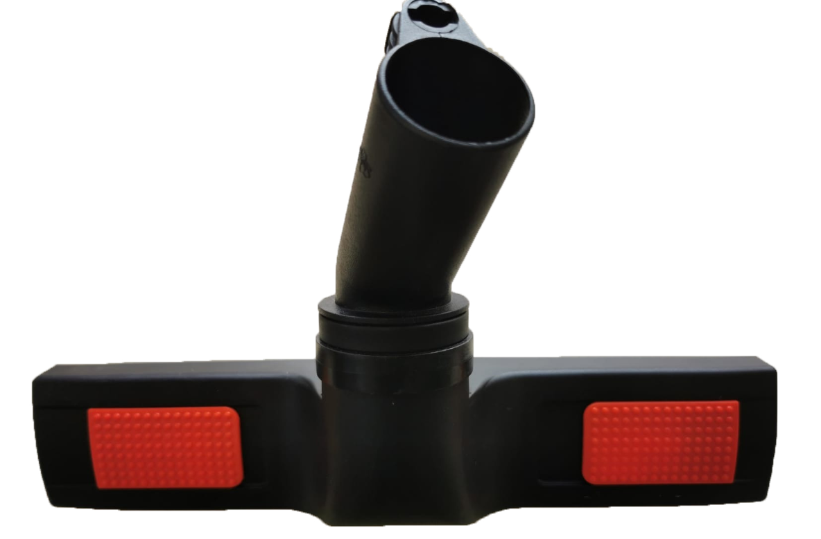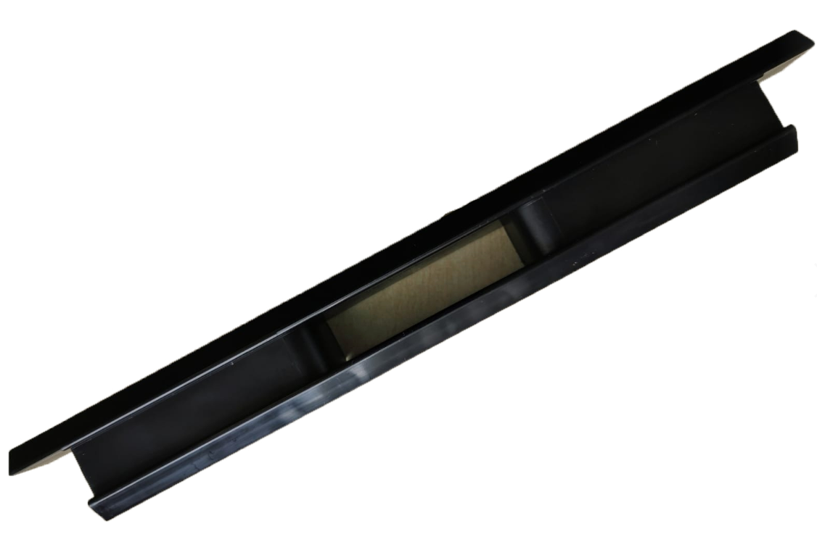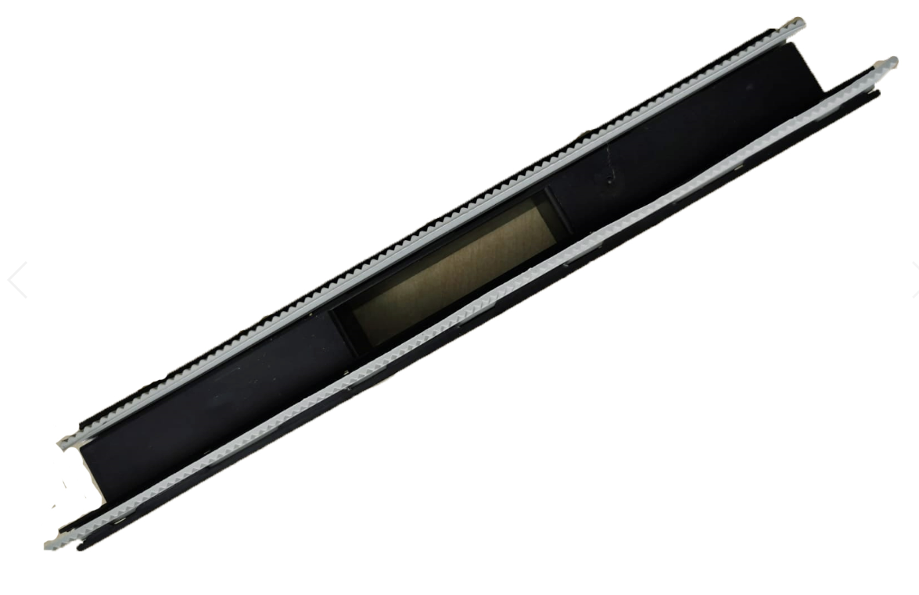
CVO x2 CVH CVM CVI
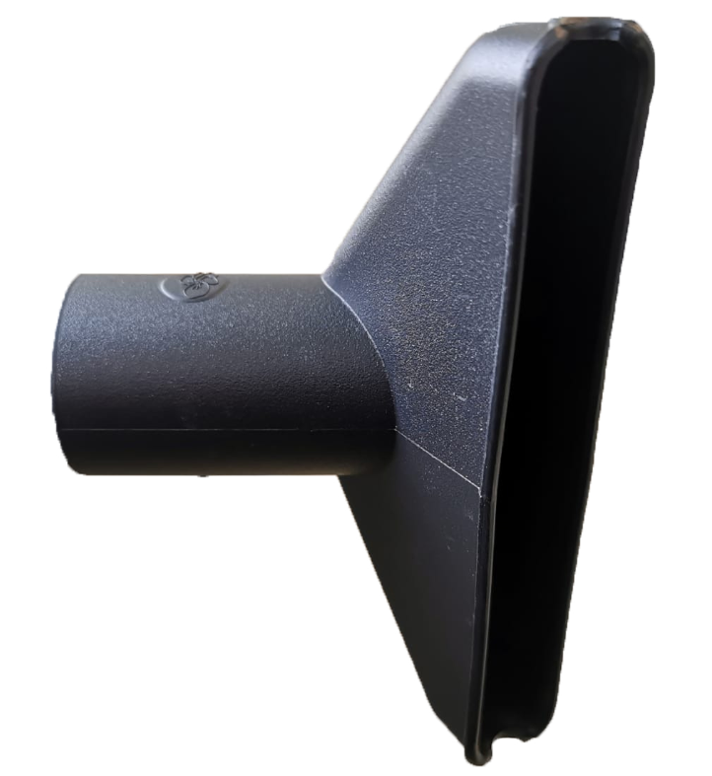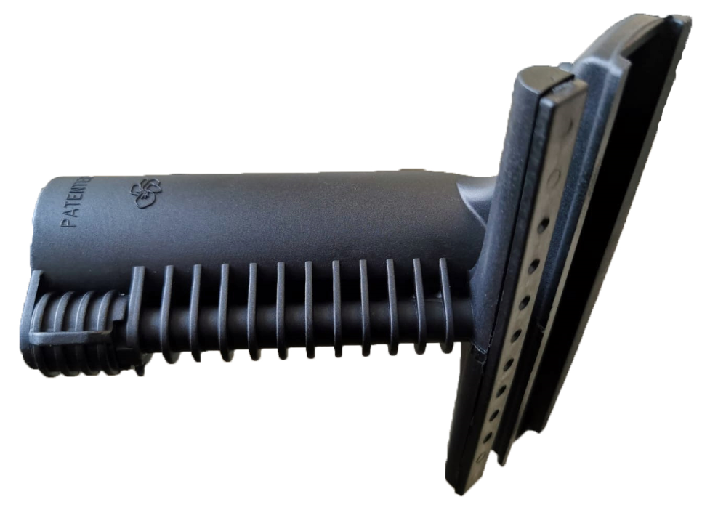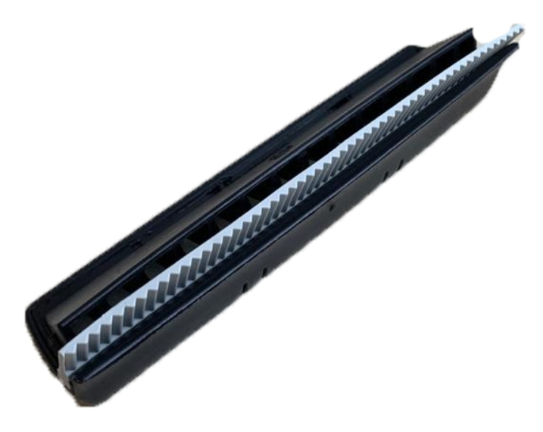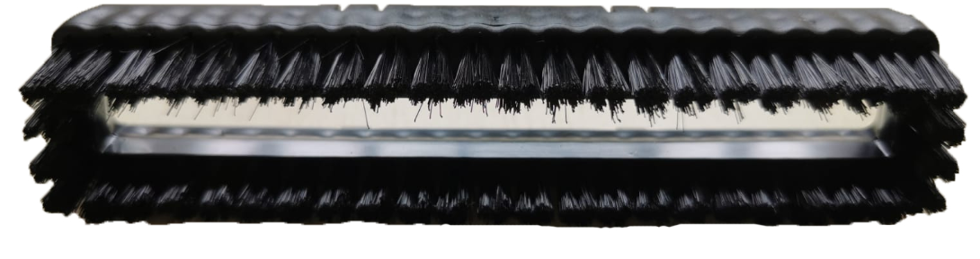
CVC CVG1 CVG2 CVG3
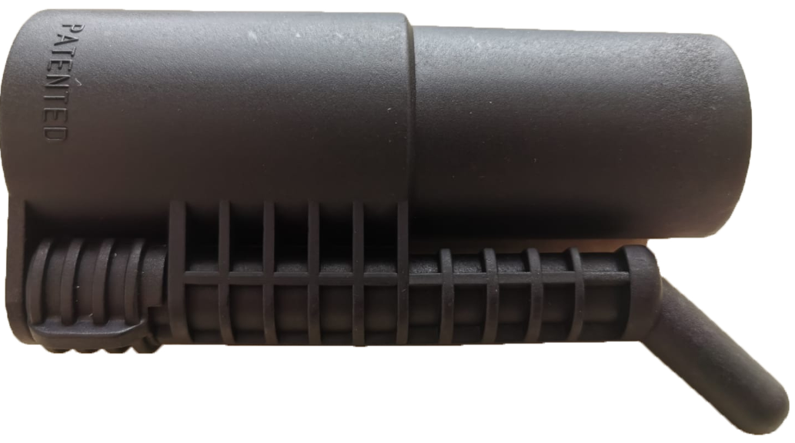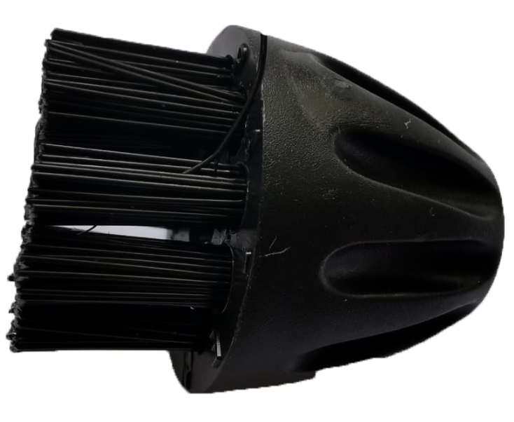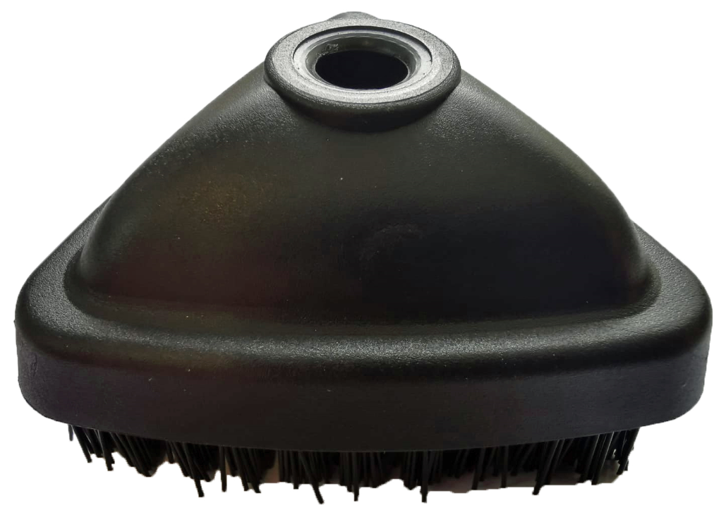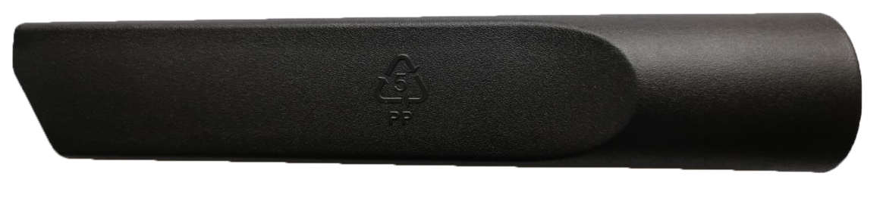
CVA CVB MGD12 CVE
If any of these items are missing or damaged when your steamer is delivered, please contact Steam Clean Systems Immediately.

